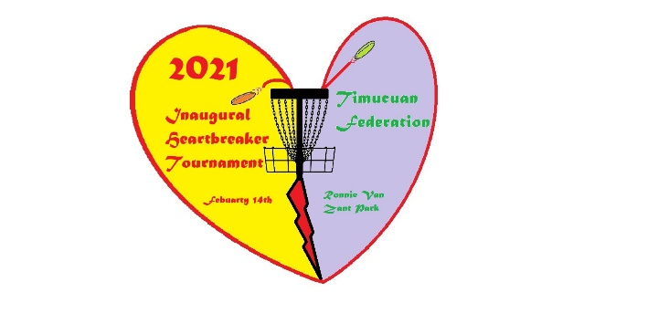
Valentines Heart Breaker Disc Golf Tournament
Tribe:___________________
Hole | PAR | Distance (ft) | Name: | Name:
1 (15) | 3 | 368
2 (16) | 3 | 322
3 (17) | 3 | 378
4 (18) | 3 | 346
5 (2) | 3 | 345
6 (3) | 3 | 388
7 (4) | 3 | 288
8 (5) | 3 | 390
9 (8) | 3 | 320
Total | 27 | 3145

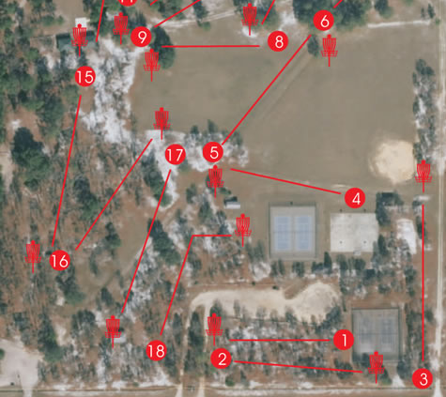

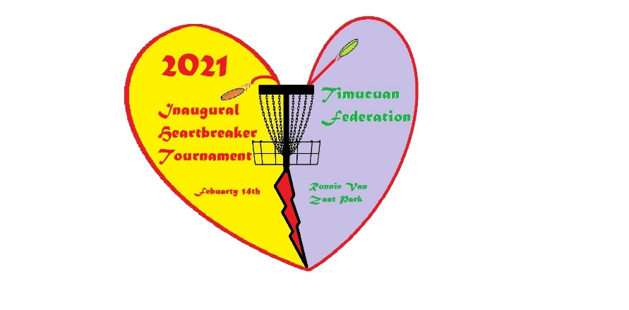
Rules:
- Have Fun!
- Disc Golf is played like regular golf, each throw counts as one and lowest score wins.
- Play begins on each hole with the player throwing from within the hole’s teeing area. A teeing area, or tee, is the area bounded by the edges of a tee pad.
- Player with lowest score on previous hole throws first.
- A disc is declared lost if the player cannot locate it within three minutes after having arrived at the area where it is thought to be. Any player in the group may begin the timing of the three minutes, and must inform the group that the timing has begun. All players in the group must assist in searching for the disc. Failure to do so is a courtesy violation
- An out-of-bounds (OB) area is an area designated by the Director from which a disc may not be played, and within which a stance may not be taken. The out-of-bounds line is part of the out-of-bounds area. Any area of the course that is not out-of-bounds is in-bounds.
- To complete a hole with a basket target, the thrower must release the disc and it must enter the target above the top of the tray and below the bottom of the chain support, and come to rest in the basket.
- All players are responsible for returning their scorecards within 30 minutes of the completion of a round, which is when the last group on the course has completed their final hole and has had reasonable time to turn in their scorecard. Failure to turn in a scorecard on time results in the addition of two penalty throws to the score of each player listed on the late scorecard.
- Best Throw available for Tee-Off. All players tee off, choose which shot is best and all play their next shots from the location of the best shot. After the first throw all players play their own lies.

