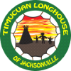 2018 Boys Fall Longhouse

Day | Time | Event | Responsible  / Comment
Friday  November 9th | 3:00 -8:00pm | Setup Camp in Bird Sanctuary | All Tribes
 | 3:00 – 3:30pm | Setup Big NSD Tepee | Chief Iron Wolf – Kiowa Tribe
 | 4:00 – 6:00pm | Setup Zip Line | Oconee
 | 11:15pm | Lights Out | All Tribes
Saturday  November 10th 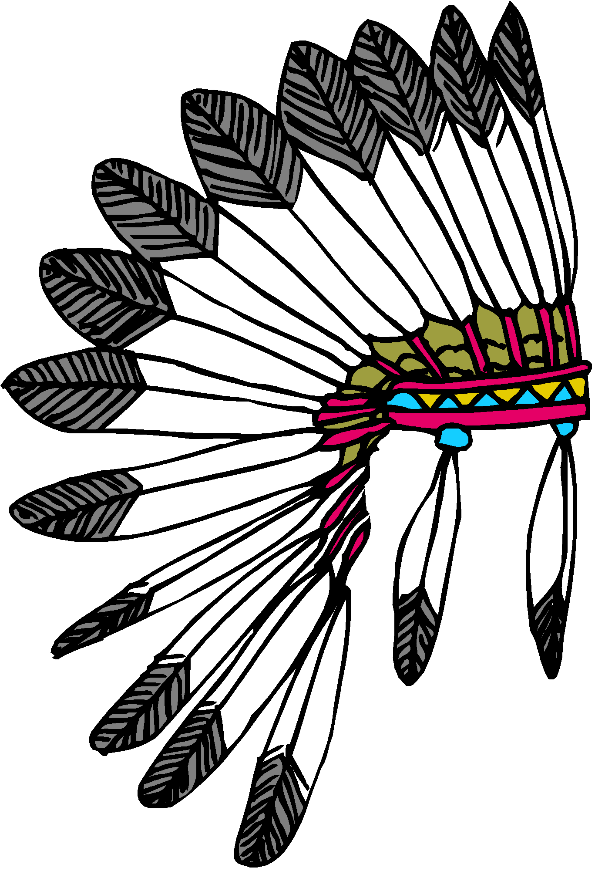  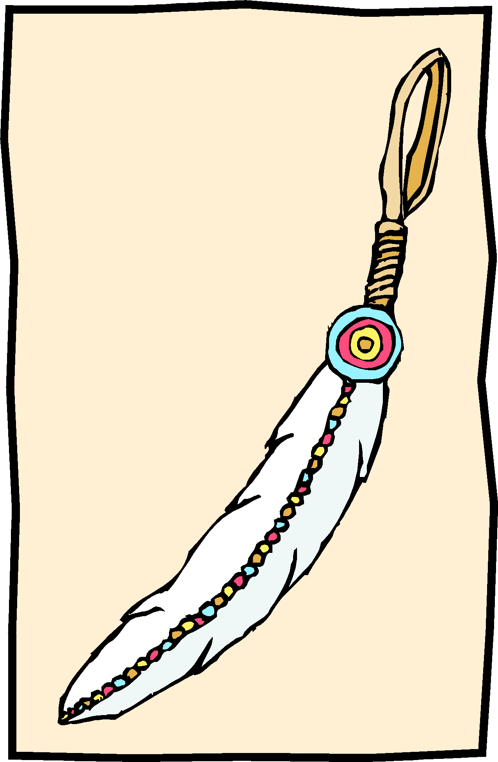  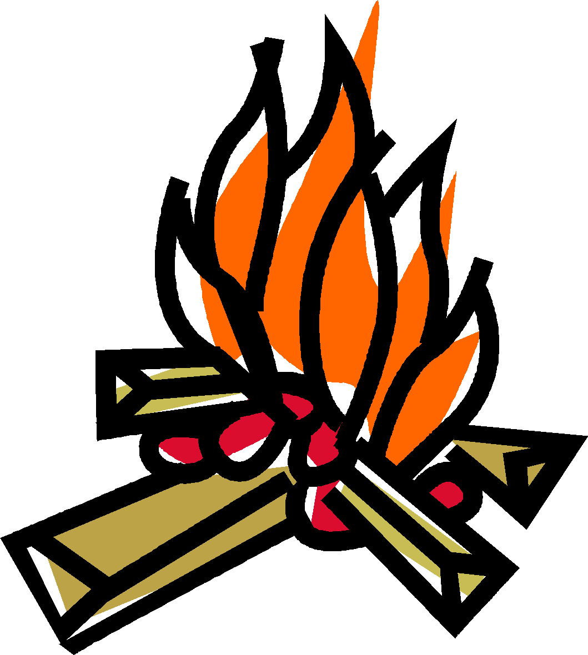 | 8:30– 9:00am | Chiefs Meeting  (Each Tribe must be represented) | All Chiefs
 | 9:00–9:30am | Opening Ceremony  Group Photo  (Bring 4 Logs per tribe for Sacred Fire) | All Tribes
 | 10:00AM-11:30AM | BB Gun Target Challenge | Shawnee
 | 10:00AM – 11:30AM | Archery – Bullseye | Mohave
 | 11:00AM – 11:30AM | War Necklaces next to Archery | Mohave
 | 11:30AM-1:00PM | Lunch | All
 | 12:30PM – 1:30PM | Face Painting – at the Mohican Campsite | Mohican
 | 1:30PM – 2:00PM | Eggcelent Throw Contest (Field next Bat house) | Ottawa
 | 2:00PM – 2:45PM | Fire Starter Challenge – next to Teepee | War Chief
 | 3:00PM – 3:45PM | Treasure Hunt  Starts at the Teepee | Crockwater and Peterbilt
 | 3:45PM- 4:45PM | Water Bomb Skills Challenge | Oconee
 | 5:00PM– 5:30PM | Nation Chief Campsite Review | Nation Chiefs - Crockwater and Peterbilt
 | 5:30PM – 6:30PM | Dinner | Chief Two Toes
 | 6:30PM– 7:30PM | Setup Luminaries | Shawnee
 | 7:30PM | Line up for Sacred Fire Walk  (Don’t Forget Tribal Tiki Torches) | All Tribes
 | 7:45PM | Begin Sacred Silent Walk(The Key Word is “Silent”) | All Tribes
 | 8:00PM – 8:45PM | Sacred Fire / Acorn Ceremony  Bring your Acorn | Federation Council
 | Immediately After | Pictures with Fed Council  (~15 min.) | Federation Council
 | 8:45PM – 9:15PM | Cleanup Luminaries | Chippewa
 | 11:45pm | Lights Out | All Tribes
 | 8:00-8:30AM | Tear Down
 | 9:00-9:30AM | Closing Ceremony/ Awards and Raffle | All Tribes
 | 9:30-10:30AM | Clean Campground | All Tribes
 | 9:30 – 10:00AM | Tear Down Big TeePee | Iron Wolf and Kiowa

Sacred Fire & Respect for the Great Spirit: Each tribe should deliver at least 4 nice, big, juicy logs to the Opening Ceremony for the Sacred Fire). During the Sacred Fire, as well as the Opening & Closing ceremony, everyone should remember to wear their vests and be respectful when someone has the Talking Stick. During the Firewalk all Big Braves and Princesses are to observe silence and reflect on their time together. Please, no flashlights, only torches
Reminders:
THIS CAMPOUT – THE NATIONS ARE ENCOURAGED TO SET UP A LARGE BONDFIRE SO THAT THE TRIBES SHARE IN A LARGE FIRE GATHERING.
~Sunset is at 5:40PM
~ Bring your vests and your new Native Sons and Daughters headbands.
~ Bring chairs to sit and glow sticks to TRADE at Sacred Fire
~ Don’t forget your Tiki Torches for the Sacred Fire Walk.
~ If you want electric power for your campsite, bring an RV plug converter.
~ Put your campfires out completely – cold to the touch – 18 inches deep.
~ Leave your campsite better than you found it. Reinforce respect for forest, field and stream with your Braves.

Your Apache and Algonquin Nation Chiefs,
Crockwater and Peterbilt
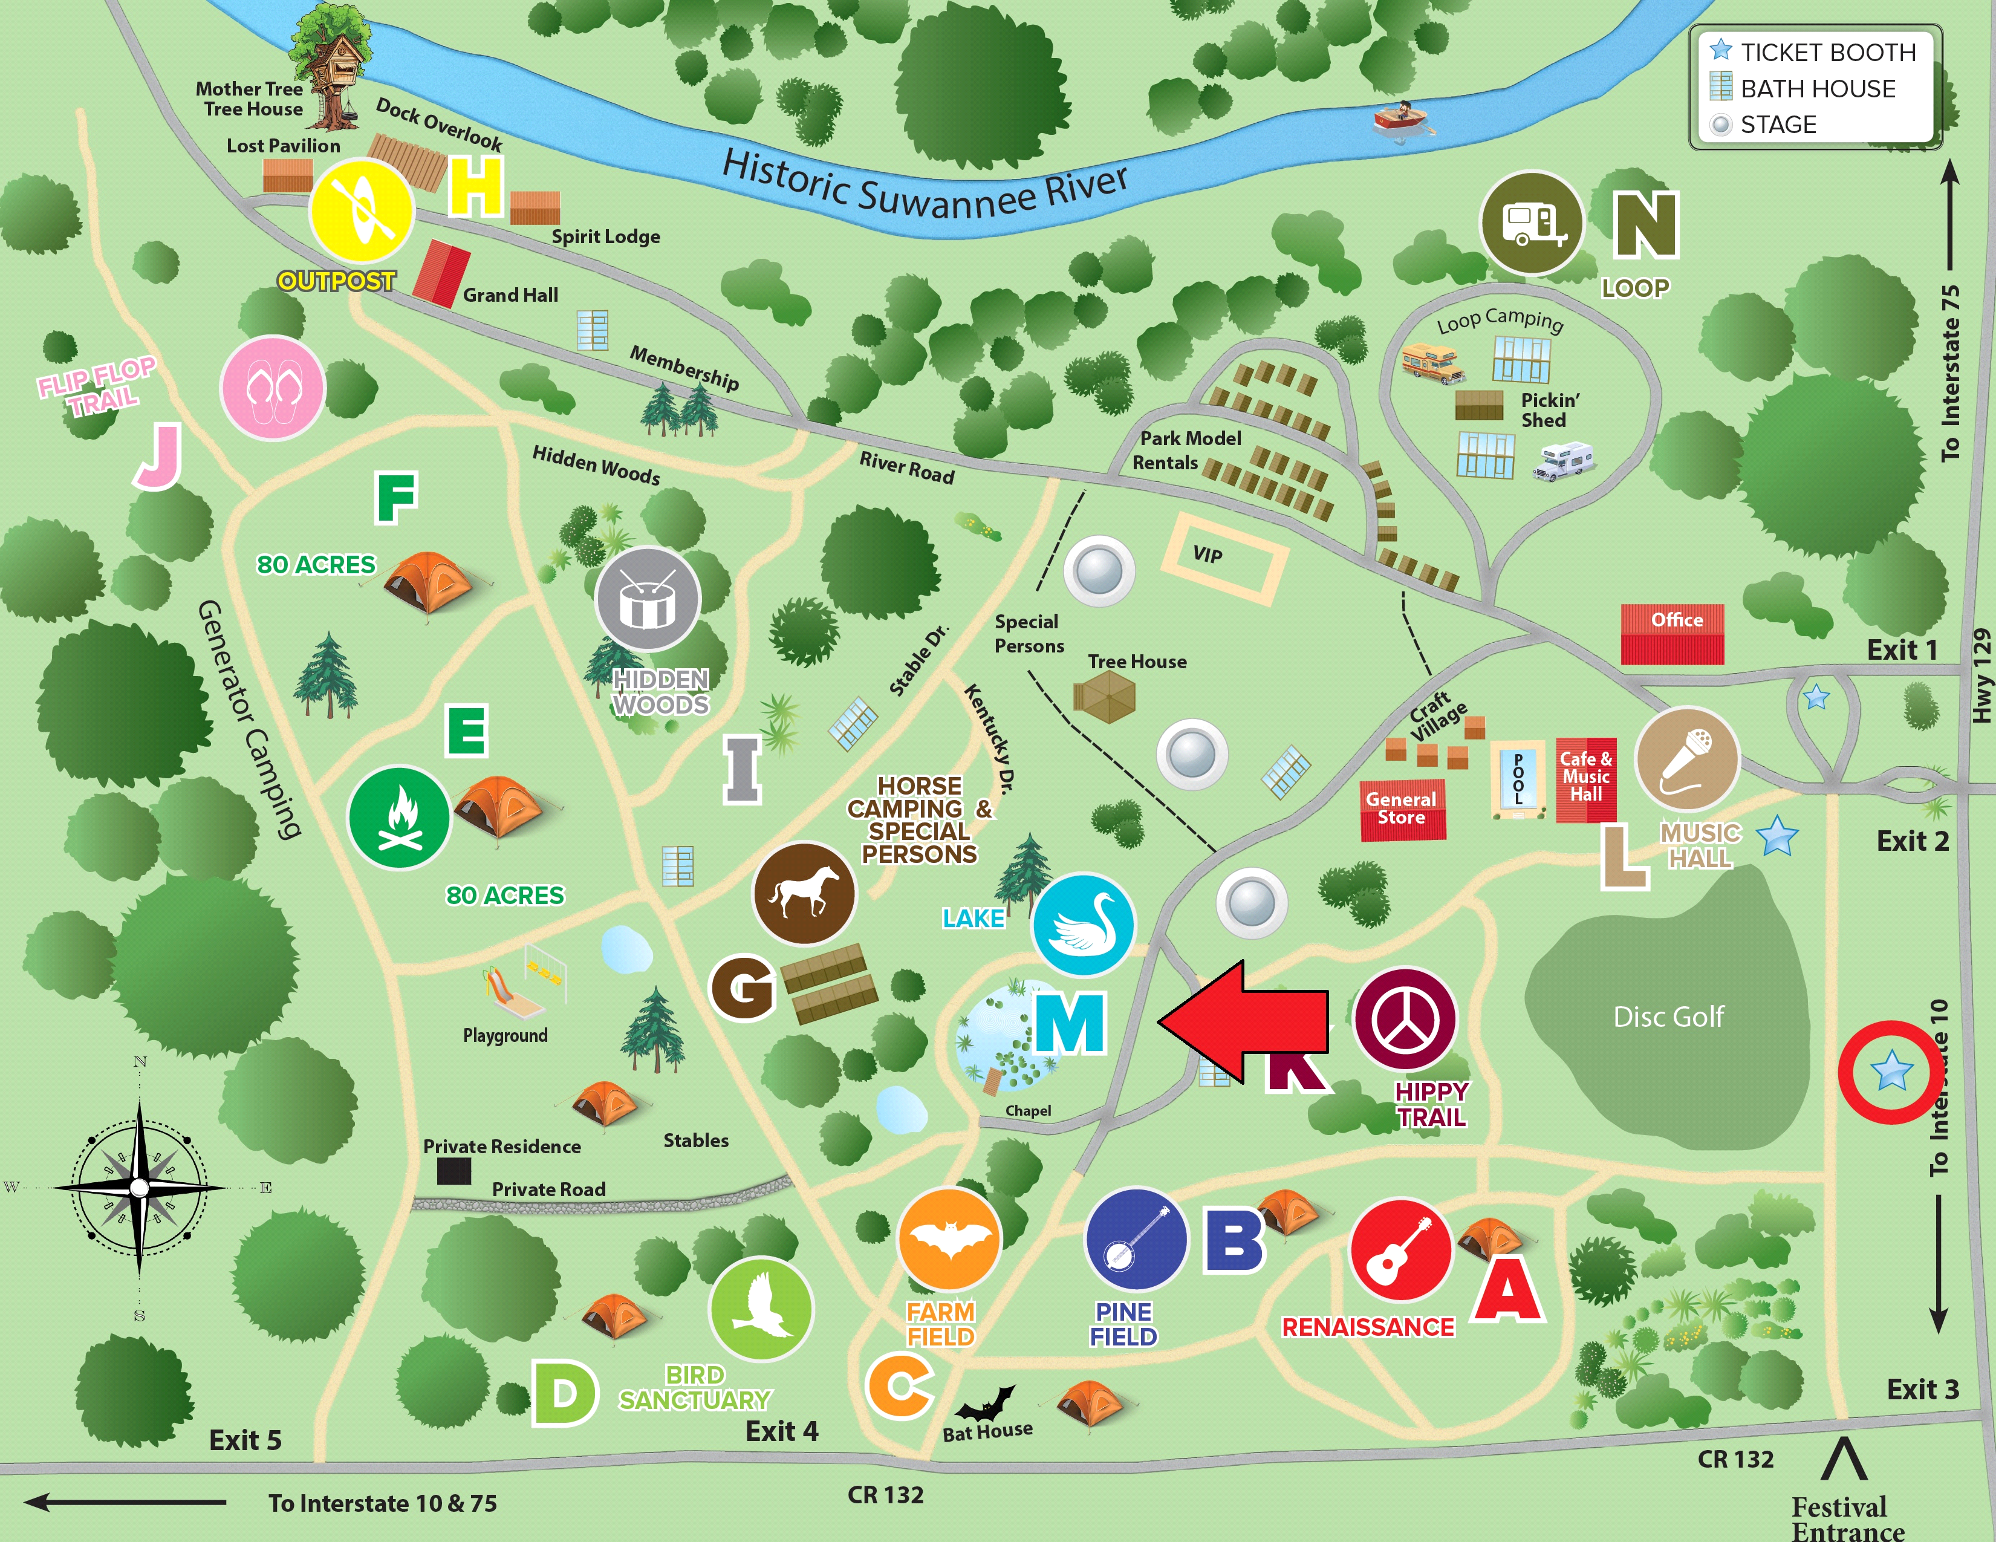
ALGONQUIN
NATION
APACHE NATION
Bathroom

