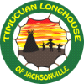 | 2021 Boys Fall  Longhouse

Day | Time | Event | Responsible  / Comment | Items Needed
Friday  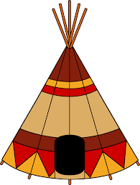  Nov 12th | 3:00 -8:00pm | Setup Camp | Check website/map for tribe assignments
 | 3:00 – 4:00pm | Setup Teepee | Mohican
 | 7:30 – 10:00pm | Movie Night at Site 52 | Chippewa
 | 11:00pm | Lights Out | Quiet - Please
Saturday  Nov 13th  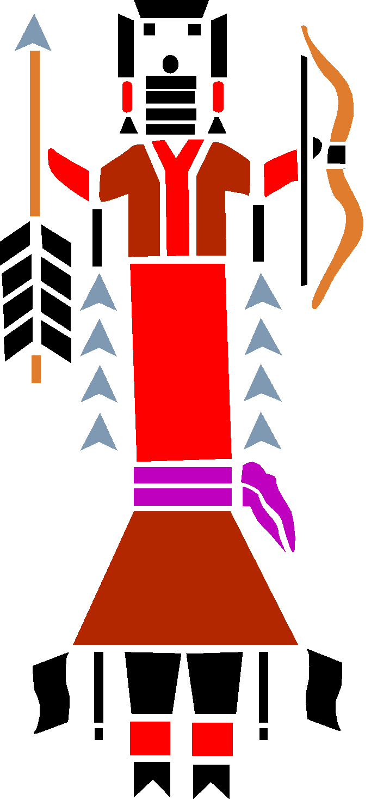 | 8:30– 9:00am | Chiefs Meeting at Flagpole  (Each Tribe must be represented) | All Chiefs | Bring 4 Logs per tribe for Sacred Fire
 | 9:30–10:00am | Opening Ceremony  Group Photo | Camping Area Flagpole | Raffle Tickets from Nation Chief per event
 | 10:30am | Begin Father / Son Walking Stick Crafting | Go find stick and start crafting
 | 11:30am | Begin Fort Building Competition | Get tarp & rope from Nation Chief
 | 12:00 - 12:45pm | Lunch | All
 | 1:00 – 2:00pm | BB Gun Competition | Oconee
 | 2:30 - 3:15pm | 3 Legged Race | Mohave
 | 3:15 – 4:00pm | Collect critters for race |  | No poisonous or venomous critters, please
 | 4:00 – 4:30pm | Big Red Critter Race | Big Red
 | 5:00 - 5:30pm | Fort Building review | Nation Chief et al
 | 5:30 – 7:00pm | Dinner | All | Smoker Trailer
 | 6:15– 7:00pm | Campsite/Walking Stick Judging | Tribal property is important
 | 7:00 – 7:30pm | Setup Luminaries | KIOWA
 | 7:00 - 8:00pm | Face Paint
 | 8:00pm | Line up for Sacred Fire Walk  (Don’t Forget Tribal Tiki Torches) | All Tribes | Wear your vests
 | 8:15pm | Begin Sacred Silent Walk (The Key Word is “Silent”) | All Tribes
 | 8:30PM – 9:30pm | Sacred Fire / Acorn Ceremony | Federation Council | Bring Acorn
 | Immediately After | Pictures with Fed Council  (~15 min.) | Federation Council
 | 9:00pm | Cleanup Luminaries | Ottawa
 | 11:00pm | Lights Out | Quiet
Sunday  Nov 14th | 8:00-8:30am | Tear Down Teepee | Shawnee
 | 9:30-10:30am | Closing Ceremony/ Awards and Raffle | All Tribes
 | ALL MORNING | Clean Campground | All Tribes
 | Please drive safely back to your families

Sacred Fire & Respect for the Great Spirit: Each chief should bring at least 4 nice, big, juicy logs to the Chief’s Meeting (for the Sacred Fire). During the Sacred Fire, as well as the Opening & Closing ceremony, everyone should remember to wear their vests and be respectful when someone has the Talking Stick. During the Firewalk all Big Braves and Princesses are to observe silence and reflect on their time together. Please, no flashlights, only torches.
Reminders:
~ Sunset is at 5:38PM
~ Bring your vests and your Native Sons and Daughters headbands.
~ Bring glow sticks to TRADE at Sacred Fire
~ Don’t forget your Tiki Torches for the Sacred Fire Walk.
~ Put your campfires out completely – cold to the touch – 18 inches deep. Bring a garden hose to make it easy!
~ Leave your campsite better than you found it. Reinforce respect for forest, field and stream with your Braves.

Your Nation Chief,
Soaring Falcon

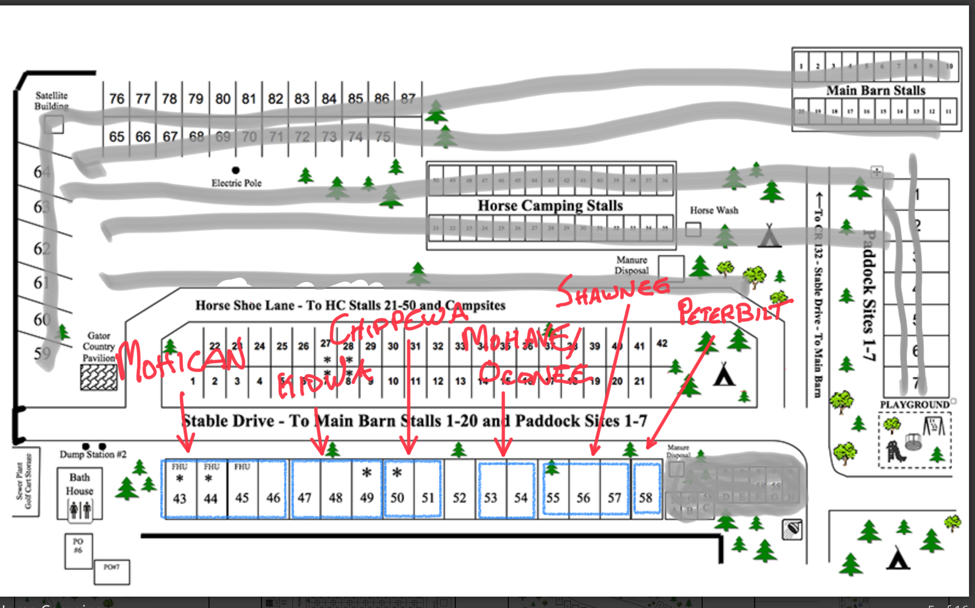

ATTENDANCE (If you are not on this list and plan to attend PLEASE sign up ASAP!)
As of 11/10 at 8:15am
Tribe | Shopping Cart | First Name | Last Name
Cherokee | Paid | John Vincent | Winkler
Cherokee | Paid | Grace | Winkler
Cherokee | Paid | Brad | Winkler
Chippewa | Paid | Rick | Murphy
Chippewa | Paid | Roryn | Murphy
Kiowa | Paid | Chris | Alberre
Kiowa | Paid | Robert | Cabrera
Kiowa | Paid | Zico | Cabrera
Kiowa | Paid | Frank | Dalessandro
Kiowa | Paid | Ryan | Dalessandro
Kiowa | Paid | Connor | Dalessandro
Kiowa | Paid | Brandon | Dressel
Kiowa | Paid | Porter | Dressel
Kiowa | Paid | Buddy | Greer
Kiowa | Paid | Zane | Greer
Kiowa | Paid | John | Maiocco
Kiowa | Paid | Luca | Maiocco
Mohave | Paid | Levi | Loft
Mohave | Paid | Anderson | Loft
Mohican | Paid | richard | brock
Mohican | Paid | Daniel | Brock
Mohican | Paid | Dylan | Brock
Mohican | Paid | Oliver | Brock
Mohican | Paid | Don | Gibson
Mohican | Paid | John | Gibson
Mohican | Paid | JACKSON | MCDANIEL
Mohican | Paid | John | Middleton
Mohican | Paid | Henry | Middleton
Mohican | Paid | Michael | Murphy
Mohican | Paid | Shepherd | Murphy
Mohican | Paid | Cooper | Nightingale
Mohican | Paid | Hayes | Nightingale
Mohican | Paid | Dylan | Shepherd
Mohican | Paid | Lori | Shepherd
Mohican | Paid | David | Studer
Mohican | Paid | Patrick | Studer
Mohican | Paid | luke | Studer
Mohican | Paid | Aaron | Thivierge
Mohican | Paid | Jack | Thivierge
Oconee | Paid | Frank | Sebregandio
Oconee | Paid | Ryder | Sebregandio
Oconee | Paid | Steve | Sharpe
Oconee | Paid | Nicholas | Sharpe
Oglala | Paid | Hannah | Schreiber
Oglala | Paid | Ava | Schreiber
Pathfinders | Paid | John | Dougherty
Pathfinders | Paid | Gabriella | Schreiber
Pathfinders | Paid | Ava | Winkler
Shawnee | Paid | Essa | Alberre
Shawnee | Paid | Raymond | Adams
Shawnee | Paid | Raymond "Finn" | Adams
Shawnee | Paid | Pat | Riley
Shawnee | Paid | Jack | Riley
Shawnee | Paid | Joseph | Riley
Shawnee | Paid | Leed | Silverfield
Shawnee | Paid | Grant | Silverfield

