How to send Mass Email to Registered Members on Single Event

Step 1: Search for Event
Before sending mass emails for a single event, you will need to find the “Event ID” using the event search feature.
- Go to nsdjax.org and click Registration in top menu to get to CircleBridge (CB).
- Login with your standard CB username and password.
- In the top menu, choose Admin and select Event Search to open the Search for Events screen.
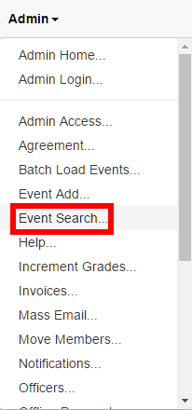

- On the Search for Events screen, ensure that the Event Name drop-down says Like and type part of the name of the desired event into the Event Name field (e.g. “Fall Longhouse” to find the event named “Girls Fall Longhouse” with event date in 2016). Then click the Grid button to perform the search.
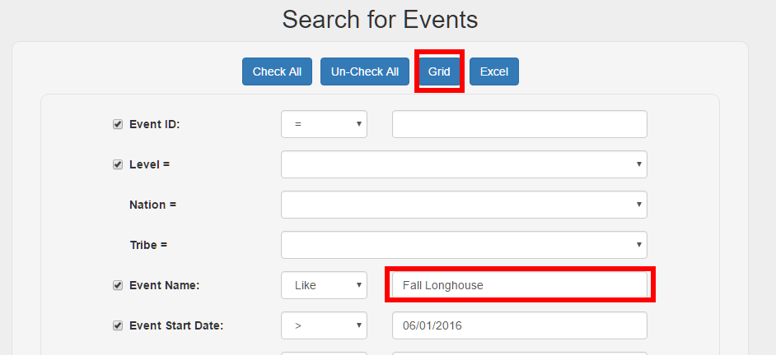

- Look through the list and find your event. Take note of the “Event ID” in the grid. You will use the “Event ID” in the next steps.
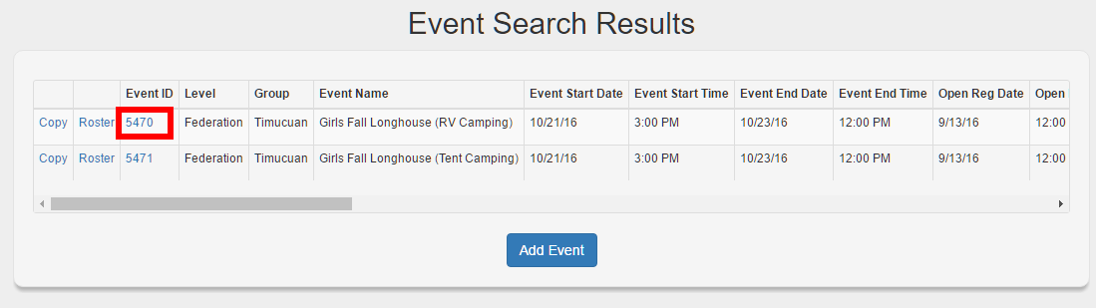
NOTE: If your desired event does not appear, try going back and changing the Event Start Date field to make sure your event is included in the list.

Step 2: Sending Mass Emails
- Once again, in the top menu, choose Admin and select Mass Email to open the Mass Email screen.
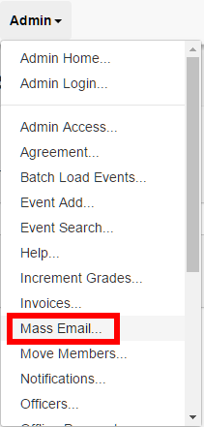

- On the Mass Email screen, type the “Event ID” you previously discovered into the Event ID field. Change “Attending” to Yes and “Shopping Cart” to Paid.
NOTE: CircleBridge only permits you to select a single event. This means that if you are sending an email to members of two CB events that compose the same actual event then you will have to do these steps multiple times, once for each CB event.
- Go to the bottom of the page and click the Search button.
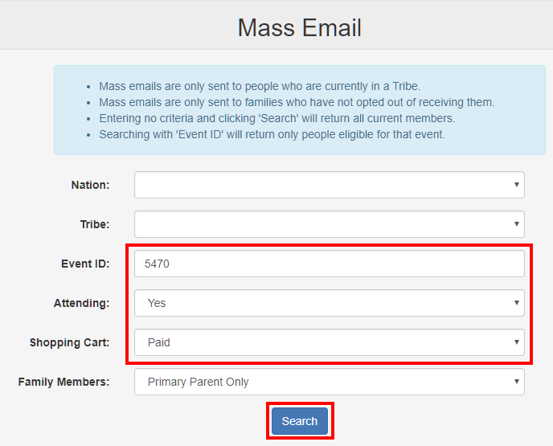
- The next screen pre-populates event information into the subject and message/body for the selected event. It also shows the number of recipients (i.e. all members matching the selections on the previous that have email addresses on their profile.
- Type a Subject, add necessary attachments using the Attach File button, and type your email message (i.e. body).
NOTE: If you are going to be sending the same email again, to another event, this is the time to copy the email message/body.

- When you are finished typing your email, click the Send button. 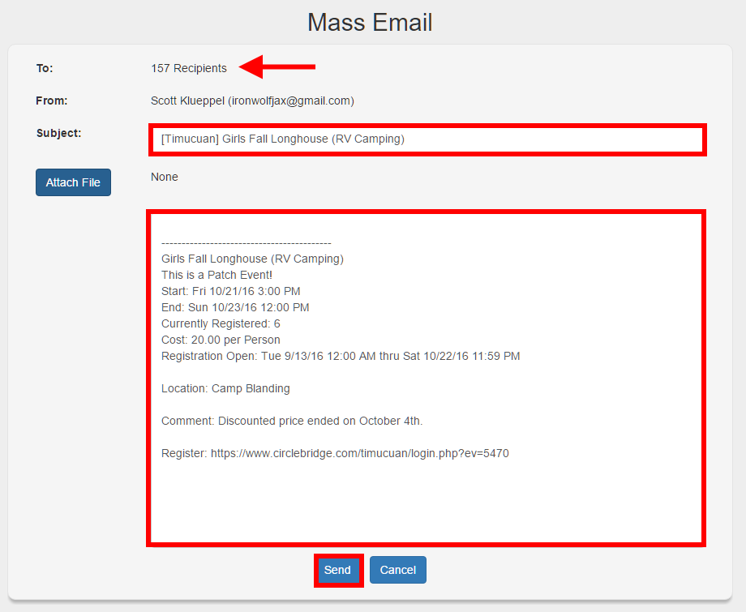

- The email will go into a send queue and CircleBridge sends them out in bulk so it may take minutes to hours before all of the emails are sent.
- If the email is not received after two hours, please contact the Timucuan Webspinner (webspinner@nsdjax.org) for assistance.

