The Jacksonville SUNS present the
Timucuan federation
Native sons & daughters
Camping in the outfield
Friday april 4th, 2014
Jacksonville suns vs. Huntsville stars
Game time- 7:05 gates open- 6:00
*the game will be followed by a fireworks show!*
For 18.50 you will receive:
- A reserved seat to the game
- A commemorative Suns game patch
- A special pass to re-enter the outfield for camping
- Free movie after the game
- A $2 ticket will be available for AT LEAST TWO PIECES OF pizza while camping….proceeds go to Alex’s Lemonade Stand
For 12.50 game and patch only
*******Camping contingent on weather******

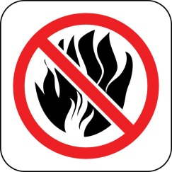
Camping reminder: stakeless tents only! no campfires!
Seating is limited so sign up now! First come…first serve!

For more information contact Big Horn Moose (Mike Russell) @ recruitmentchief@timucuan.org or call (904) 330-4025

