How to send Mass Email to Tribe or Nation

Step 1: Member Email Verification
Before sending mass emails, it is best to make sure all tribe/nation members have an email address in their profile.
- Go to nsdjax.org and click Registration in top menu to get to CircleBridge (CB).
- Login with your standard CB username and password.
- In the top menu, choose Admin and select People Search to open the Search People screen.
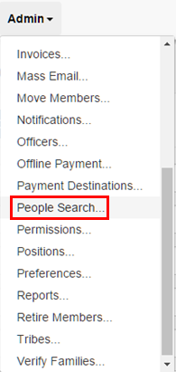

- On the Search People screen, use the drop-downs to select a single tribe or nation to receive your email (e.g. Tribe = Pathfinders or Nation = Algonquin).
NOTE: CircleBridge only permits you to select a single tribe or nation. This means that if you are searching for to “All Girls Nations” you will have to do these steps four times, once for each nation (including the now non-existent Iroquois since CB can’t move tribes).

- Go to bottom of the page, click the Grid button to display the matching members on your screen.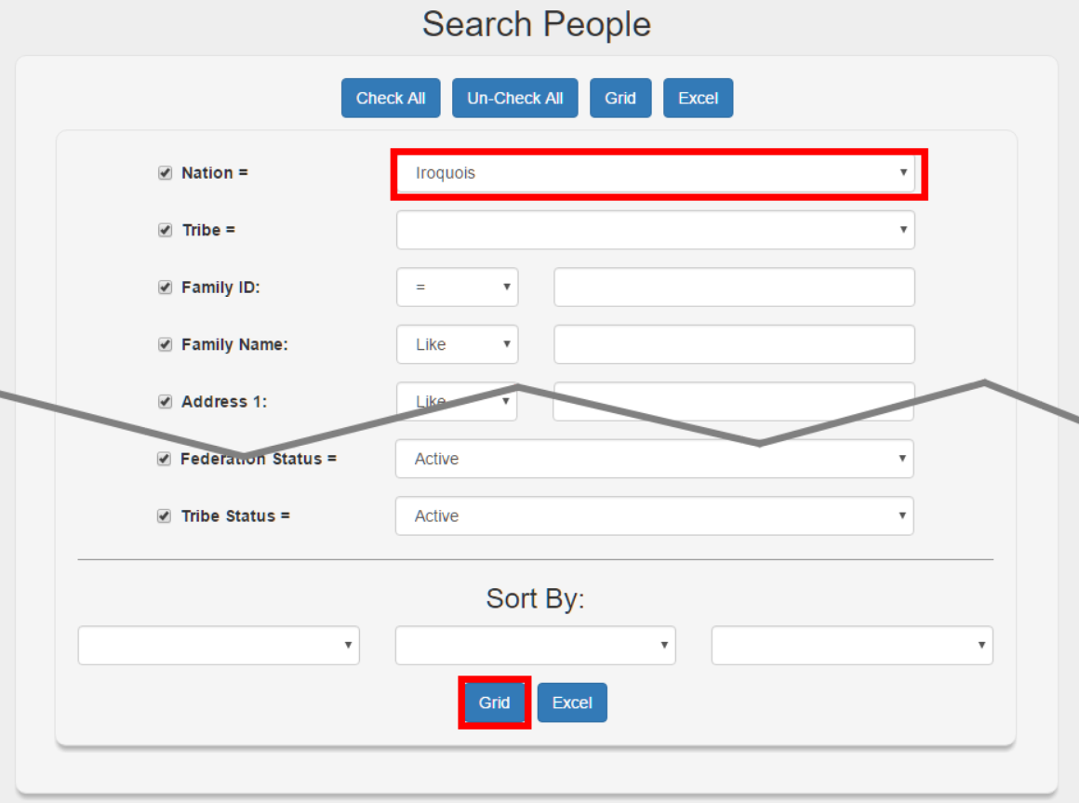
NOTE: You can also click on the Excel button to output the results to an Excel Spreadsheet.
- Confirm the names and email addresses for all members matching the selected criteria to make sure you made the correct selection.

Sending Mass Emails
- Once again, in the top menu, choose Admin and select Mass Email to open the Mass Email screen.
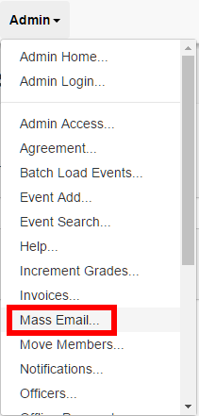

- On the Mass Email screen, use the drop-downs to select a single tribe or nation to receive your email (e.g. Tribe = Pathfinders or Nation = Algonquin).
NOTE: CircleBridge only permits you to select a single tribe or nation. This means that if you are sending an email to “All Girls Nations” you will have to do these steps four times, once for each nation (including the now non-existent Iroquois since CB can’t move tribes).
- Go to the bottom of the page, and click the Search button.
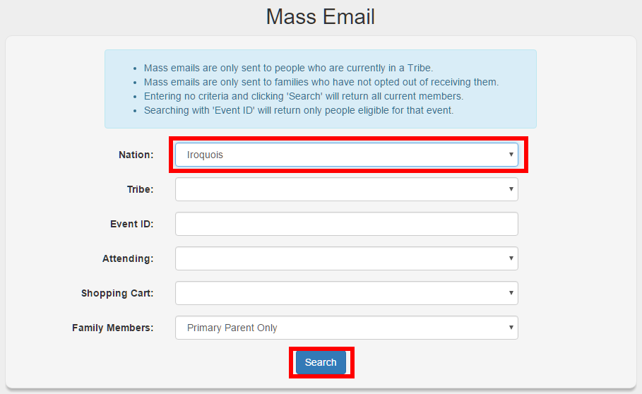
- The next screen shows the number of recipients (i.e. all members matching the selections on the previous that have email addresses on their profile. Verify that this number is correct compared to your earlier People Search.
- Type a Subject, add necessary attachments using the Attach File button, and type your email message (i.e. body).
NOTE: If you are going to be sending the same email again, to another tribe or nation, this is the time to copy the email message/body.

- When you are finished typing your email, click the Send button.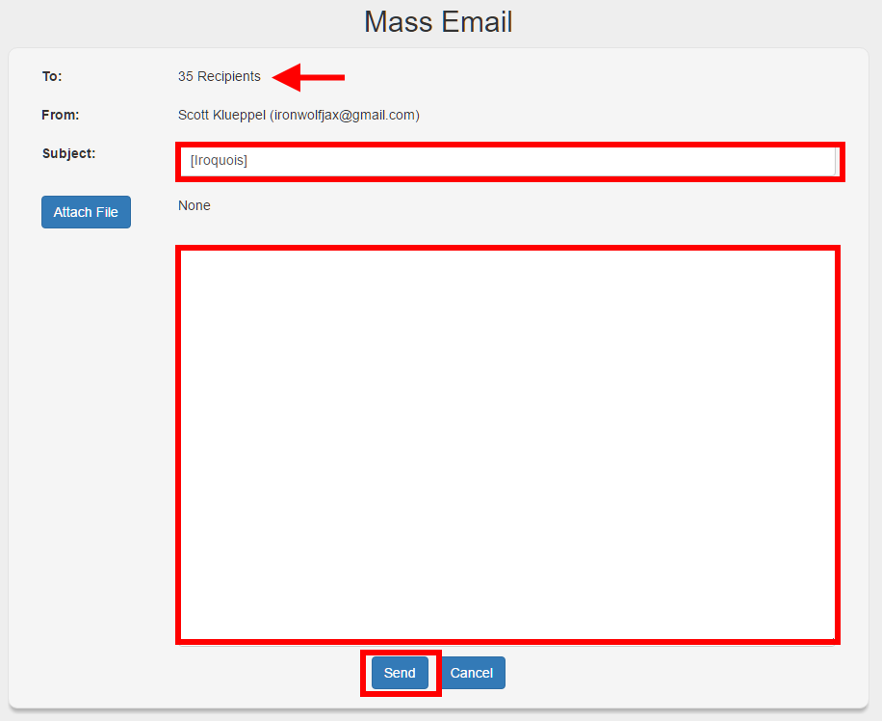

- The email will go into a send queue and CircleBridge sends them out in bulk so it may take minutes to hours before all of the emails are sent.
- If the email is not received after two hours, please contact the Timucuan Webspinner (webspinner@nsdjax.org) for assistance.

