How to generate a customized roster for a single event

Step 1: Search for Event
Before sending mass emails for a single event, you will need to find the “Event ID” using the event search feature.
- Go to nsdjax.org and click Registration in top menu to get to CircleBridge (CB).
- Login with your standard CB username and password.
- In the top menu, choose Admin and select Event Search to open the Search for Events screen.
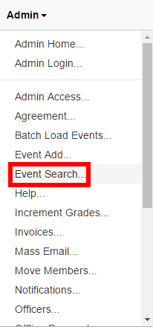

- On the Search for Events screen, ensure that the Event Name drop-down says Like and type part of the name of the desired event into the Event Name field (e.g. “Fall Longhouse” to find the event named “Girls Fall Longhouse” with event date in 2016). Then click the Grid button to perform the search.
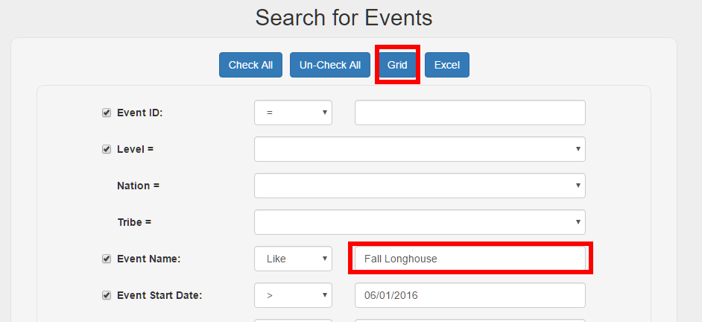

- Look through the list and find your event. Click Roster for your event.
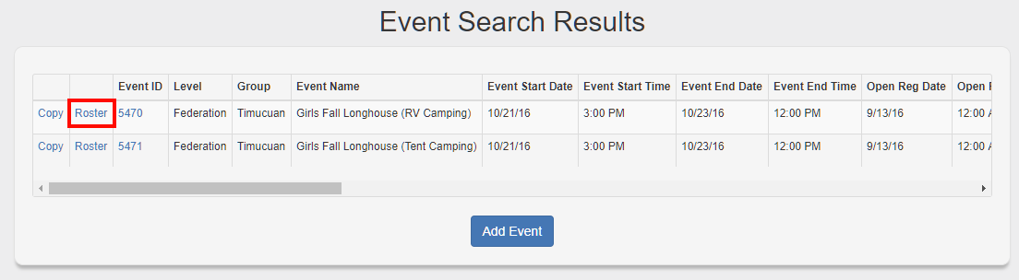
NOTE: If your desired event does not appear, try going back and changing the Event Start Date field to make sure your event is included in the list.

Step 2: Build and Export the Roster
- On the Search Event Roster screen, you are presented with many fields, each with a checkbox on the left. Any fields that you want to include in your exported roster need to have a checkmark. Any fields that you want to use as filters need to have a value.
- Clear the checkmark for any fields that are not needed for your use (e.g. “Family ID” or “Physician”). Here we have cleared the checkboxes for “Accepted”, “Shopping Cart”, “Registration Date”, and “Family ID”, so those fields will not be present in the Excel file.
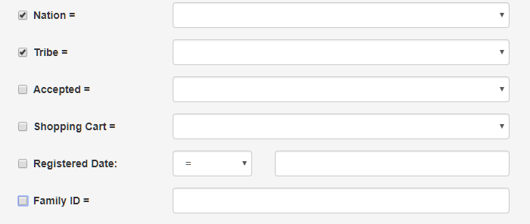

- Now add the filters you need to generate your roster. You are most likely only interested in those members that registered and paid to attend. To accomplish that, add the following filter values for “Accepted” and “Shopping Cart”. After applying these two filters, our screen will now look like this:
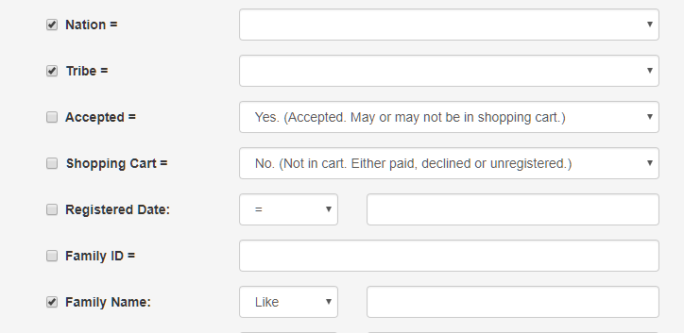

- When you have checked/unchecked your desired fields, and provided the necessary filters, click the Excel button at the top to generate and export the Excel file.
